## ****Euler Graph-****

An Euler graph may be defined as-

|  |
| --- |
| Any connected graph is called as an Euler Graph if and only if all its vertices are of even degree.  **OR**  An Euler Graph is a connected graph that contains an Euler Circuit. |

### **Euler Graph Example**

The following graph is an example of an Euler graph-

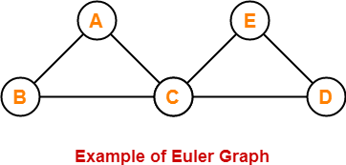

Here,

* This graph is a connected graph and all its vertices are of even degree.
* Therefore, it is an Euler graph.

Alternatively, the above graph contains an Euler circuit BACEDCB, so it is an Euler graph.

**Euler Path-**

Euler path is also known as **Euler Trail** or **Euler Walk**.

* If there exists a [**Trail**](https://www.gatevidyalay.com/walk-in-graph-theory/) in the connected graph that contains all the edges of the graph, then that trail is called as an Euler trail.

**OR**

* If there exists a walk in the connected graph that visits every edge of the graph exactly once with or without repeating the vertices, then such a walk is called as an Euler walk.

|  |
| --- |
| **NOTE** A graph will contain an Euler path if and only if it contains at most two vertices of odd degree. |

### **Euler Path Examples-**

Examples of Euler path are as follows-

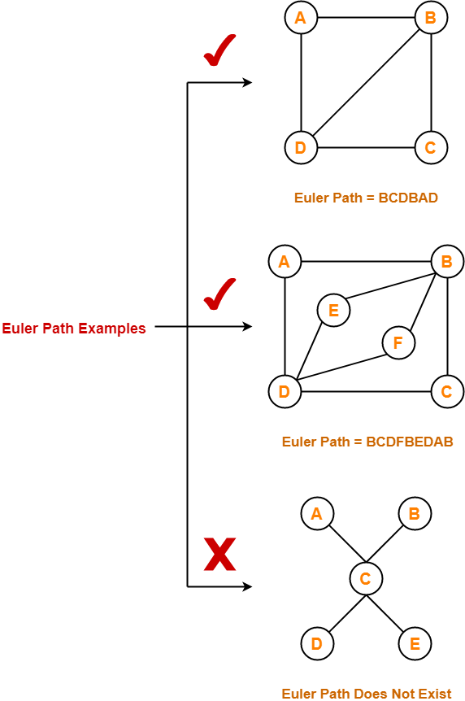

## Euler Circuit

Euler circuit is also known as **Euler Cycle** or **Euler Tour**.

* If there exists a [**Circuit**](https://www.gatevidyalay.com/walk-in-graph-theory/) in the connected graph that contains all the edges of the graph, then that circuit is called as an Euler circuit.

**OR**

* If there exists a walk in the connected graph that starts and ends at the same vertex and visits every edge of the graph exactly once with or without repeating the vertices, then such a walk is called as an Euler circuit.

**OR**

* An Euler trail that starts and ends at the same vertex is called as an Euler circuit.

**OR**

* A closed Euler trail is called as an Euler circuit.

### **NOTE**

A graph will contain an Euler circuit if and only if all its vertices are of even degree.

### **Euler Circuit Examples**

Examples of Euler circuit are as follows-

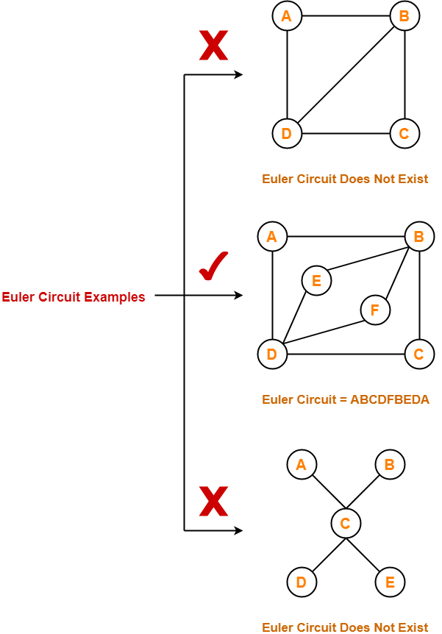

## ****Important Notes****

### **Note-01:**

To check whether any graph is an Euler graph or not, any one of the following two ways may be used-

* If the graph is connected and contains an Euler circuit, then it is an Euler graph.
* If all the vertices of the graph are of even degree, then it is an Euler graph.

### **Note-02:**

To check whether any graph contains an Euler circuit or not,

* Just make sure that all its vertices are of even degree.
* If all its vertices are of even degree, then graph contains an Euler circuit otherwise not.

### **Note-03:**

To check whether any graph is a semi-Euler graph or not,

* Just make sure that it is connected and contains an Euler trail.
* If the graph is connected and contains an Euler trail, then graph is a semi-Euler graph otherwise not.

### **Note-04:**

To check whether any graph contains an Euler trail or not,

* Just make sure that the number of vertices in the graph with odd degree are not more than 2.
* If the number of vertices with odd degree are at most 2, then graph contains an Euler trail otherwise not.

### **Note-05:**

* A graph will definitely contain an Euler trail if it contains an Euler circuit.
* A graph may or may not contain an Euler circuit if it contains an Euler trail.

### **Note-06:**

* An Euler graph is definitely be a semi-Euler graph.
* But a semi-Euler graph may or may not be an Euler graph.

## ****PRACTICE PROBLEMS BASED ON EULER GRAPHS IN GRAPH THEORY-****

## ****Problems-****

Which of the following is / are Euler Graphs?

## https://www.gatevidyalay.com/wp-content/uploads/2018/06/Practice-Problems-Based-On-Euler-Graph-in-Graph-Theory.png

**Hamiltonian Graph-**

A Hamiltonian graph may be defined as-

|  |
| --- |
| If there exists a closed walk in the connected graph that visits every vertex of the graph exactly once  (except starting vertex) without repeating the edges,  then such a graph is called as a Hamiltonian graph.  **OR**  Any connected graph that contains a Hamiltonian circuit is called as a Hamiltonian Graph. |

### **Hamiltonian Graph Example-**

The following graph is an example of a Hamiltonian graph-

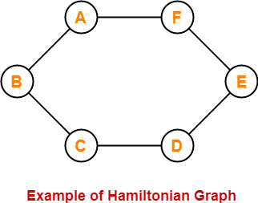

Here,

* This graph contains a closed walk ABCDEFA.
* It visits every vertex of the graph exactly once except starting vertex.
* The edges are not repeated during the walk.
* Therefore, it is a Hamiltonian graph.

Alternatively, there exists a Hamiltonian circuit ABCDEFA in the above graph, therefore it is a Hamiltonian graph.

**Hamiltonian Path-**

* If there exists a walk in the connected graph that visits every vertex of the graph exactly once without repeating the edges, then such a walk is called as a Hamiltonian path.

**OR**

* If there exists a [**Path**](https://www.gatevidyalay.com/walk-in-graph-theory/) in the connected graph that contains all the vertices of the graph, then such a path is called as a Hamiltonian path.

|  |
| --- |
| **NOTE** In Hamiltonian path, all the edges may or may not be covered but edges must not repeat. |

### **Hamiltonian Path Examples-**

Examples of Hamiltonian path are as follows-

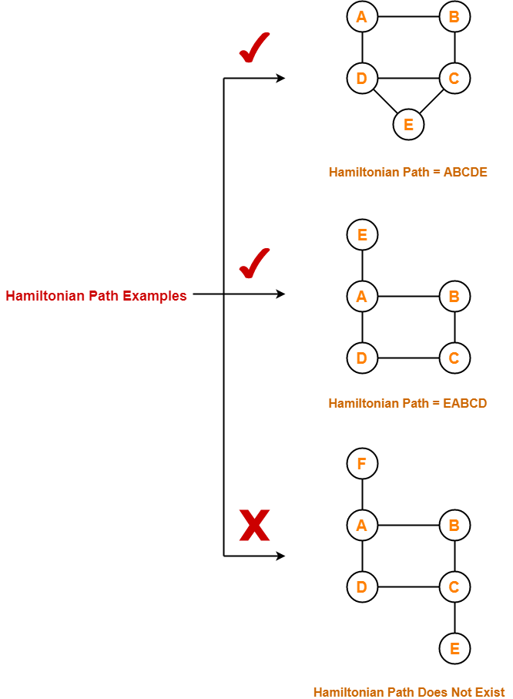

## Hamiltonian Circuit-

Hamiltonian circuit is also known as **Hamiltonian Cycle**.

* If there exists a walk in the connected graph that visits every vertex of the graph exactly once (except starting vertex) without repeating the edges and returns to the starting vertex, then such a walk is called as a Hamiltonian circuit.

**OR**

* If there exists a [**Cycle**](https://www.gatevidyalay.com/walk-in-graph-theory/) in the connected graph that contains all the vertices of the graph, then that cycle is called as a Hamiltonian circuit.

**OR**

* A Hamiltonian path which starts and ends at the same vertex is called as a Hamiltonian circuit.

**OR**

* A closed Hamiltonian path is called as a Hamiltonian circuit.

### **Hamiltonian Circuit Examples-**

Examples of Hamiltonian circuit are as follows-

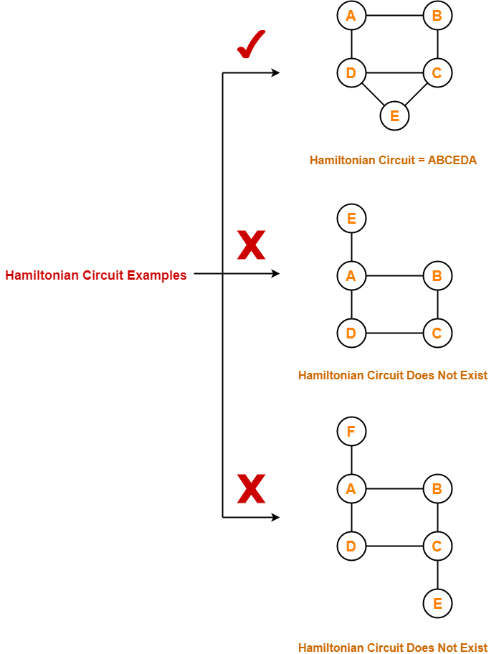

**Important Notes-**

* Any Hamiltonian circuit can be converted to a Hamiltonian path by removing one of its edges.
* Every graph that contains a Hamiltonian circuit also contains a Hamiltonian path but vice versa is not true.
* There may exist more than one Hamiltonian paths and Hamiltonian circuits in a graph.

**PRACTICE PROBLEMS BASED ON HAMILTONIAN GRAPHS IN GRAPH THEORY-**

**Problems-**

Which of the following is / are Hamiltonian graphs?

